**Data Analysis Report:**

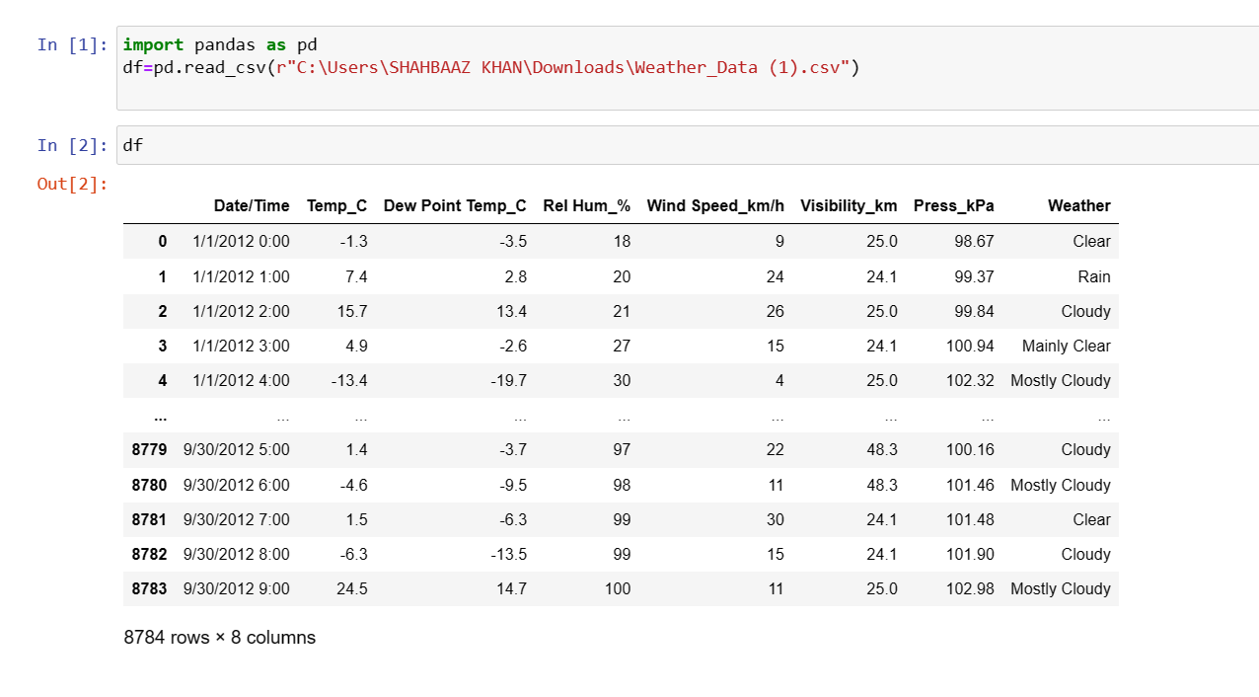

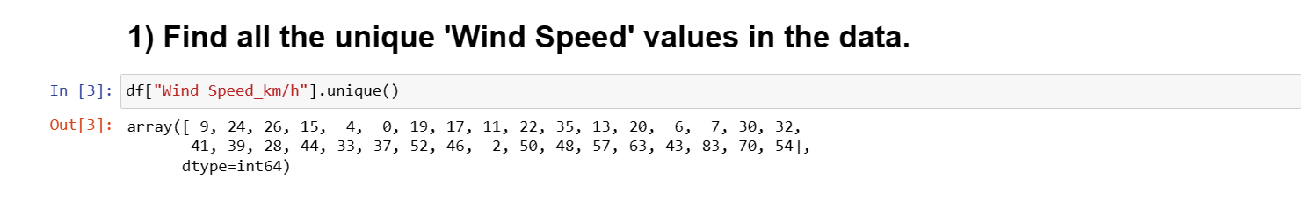

* **Syntax:df[“Column_name”].unique().**
* The unique function in pandas is used to find the unique values from a series. A series is a single column of a data frame.

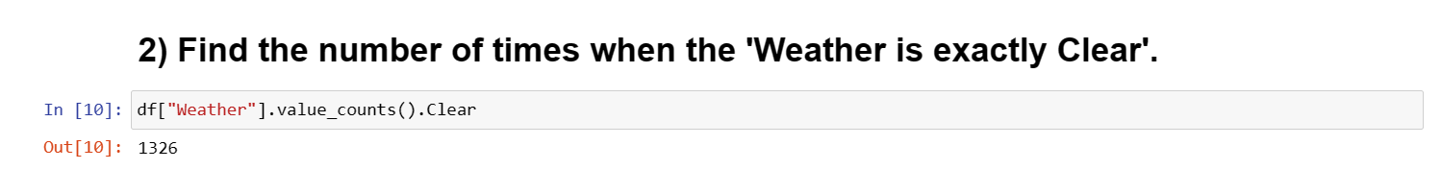

* **Syntax:df[“column_name”].value_counts().clear**
* weather condition i.e, weather is equal to clear. Value_counts() is use to count the single value at a time.
* 1326 times repeated the weather is exactly clear.

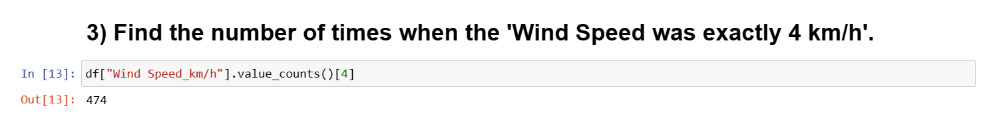

* Syntax:df[“column_name”].value_counts()[value].
* 474 times Wind speed is having 4km/h.

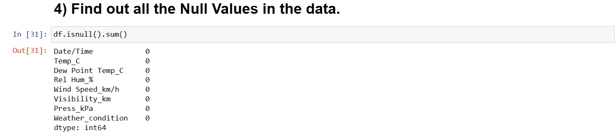

**Syntax: df.isnull() .**

Isnull() is use to heck to nulls values in the dataframe.

In the above, we don’t have null values.sum() is use to count the values.

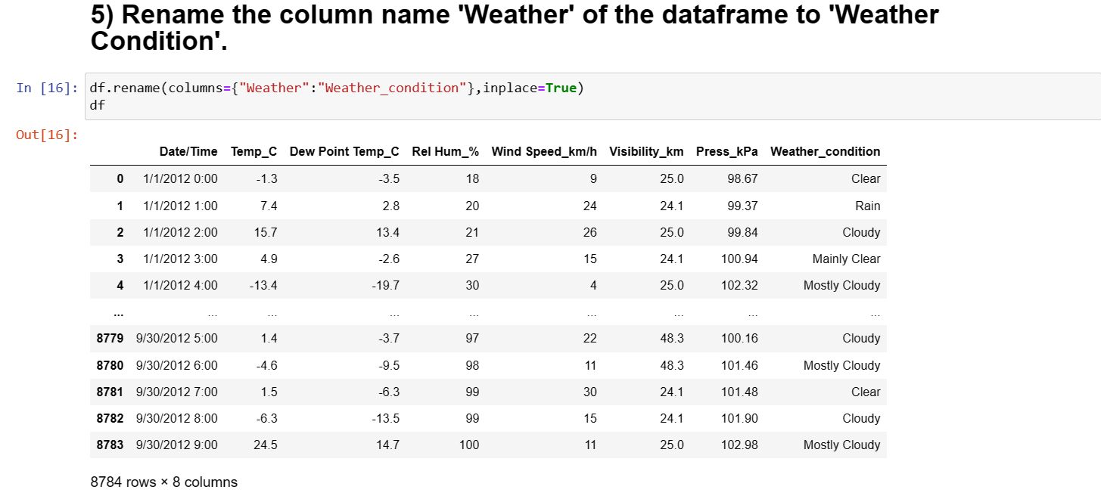

**Syntax:df.raname(column={”column_name”:”new_column_name”}).**

By using rename() we can change the present column name to new column name.In the above,we change the weather name to weather_condition.

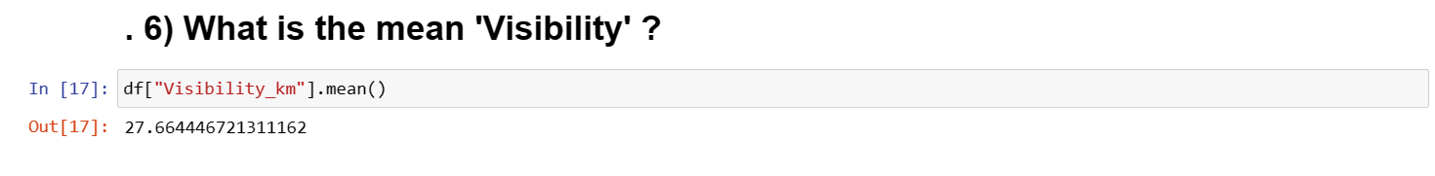

Syntax:df[“column_name”].mean().

Finding the mean of the Visibility by using mean() function.

Mean give the average value.

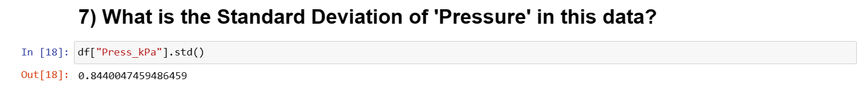

**Syntax:df[“column_name”]. std().**

Finding the Standard Deviation of the Pressure.

The standard deviation is the average amount of variability in your dataset.It tells ,on average,how far each value lies from the mean.

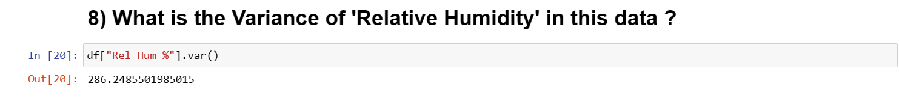

**Syntax:df[“Column_name”].var().**

Finding the variance of the Relative Humidity.

Variance is a measure of how the data points is differ from mean.

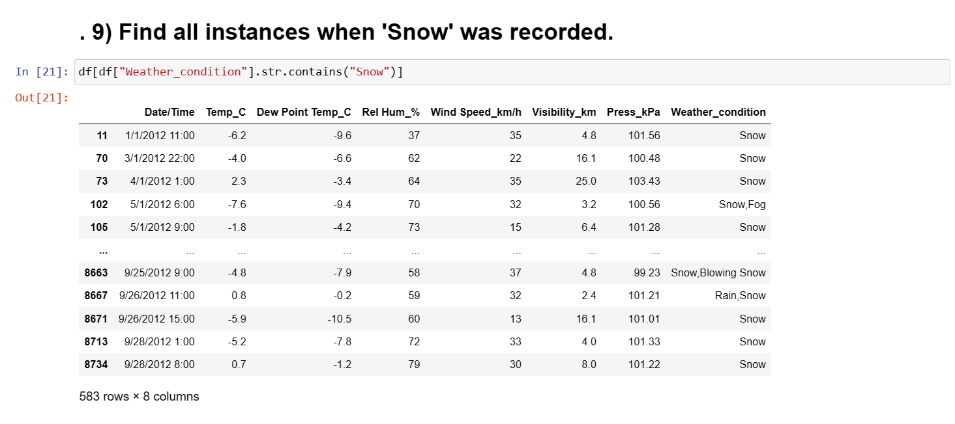

**Syntax:df[“column_name”].str.contains(“value”).**

Finding the weather_condtion is equal to snow.

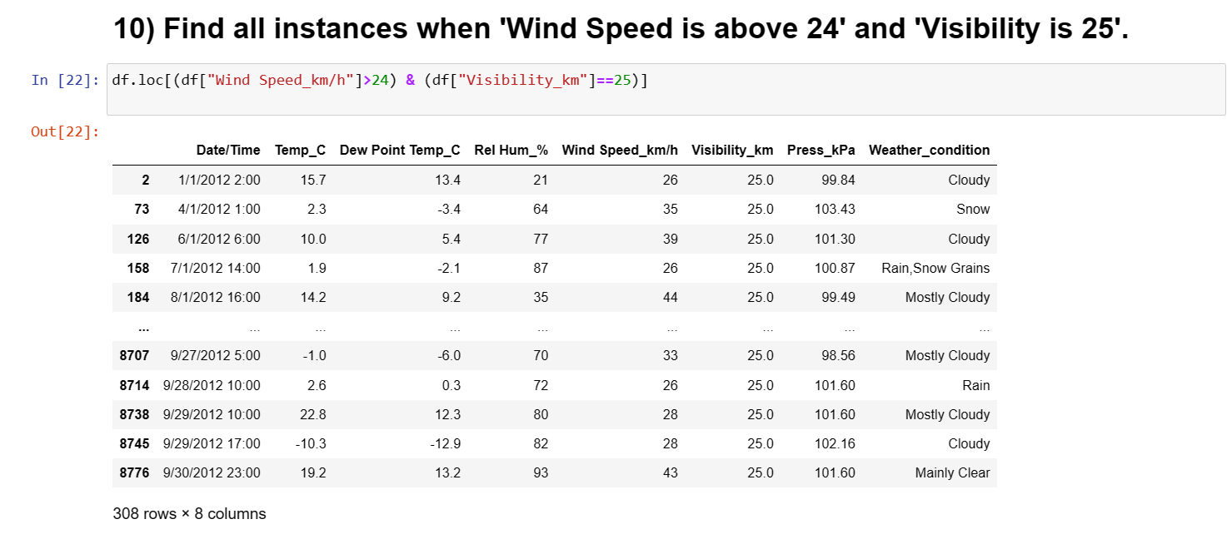

**Syntax: df.loc()**

**.loc()**  
Pandas provide various methods to have purely label based indexing. When slicing, the end bound is also included. Integers are valid labels, but they refer to the label and not the position.

* location, which is used to retrieve the data if the index is in String/character.
* In thee above ,use the condition to compare the values and to get the wind speed and visibility values.

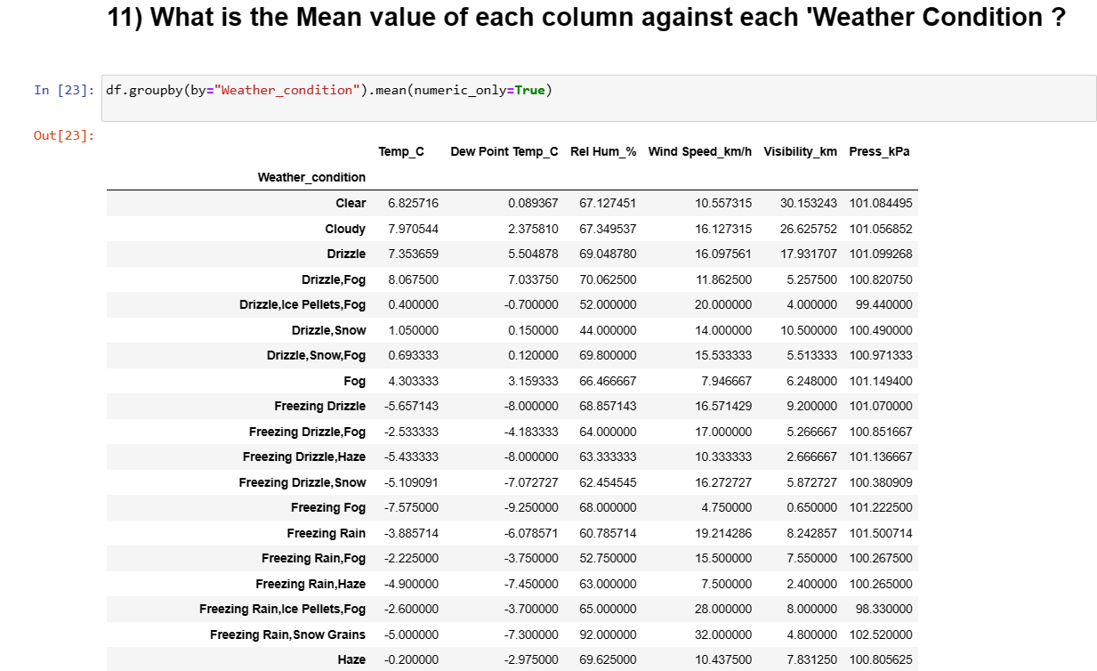

**Syntax: df.groupby(by=”column_name”).mean()**

We find the mean values of the each column against the weather_condition .Weather_condition is set to be the index.

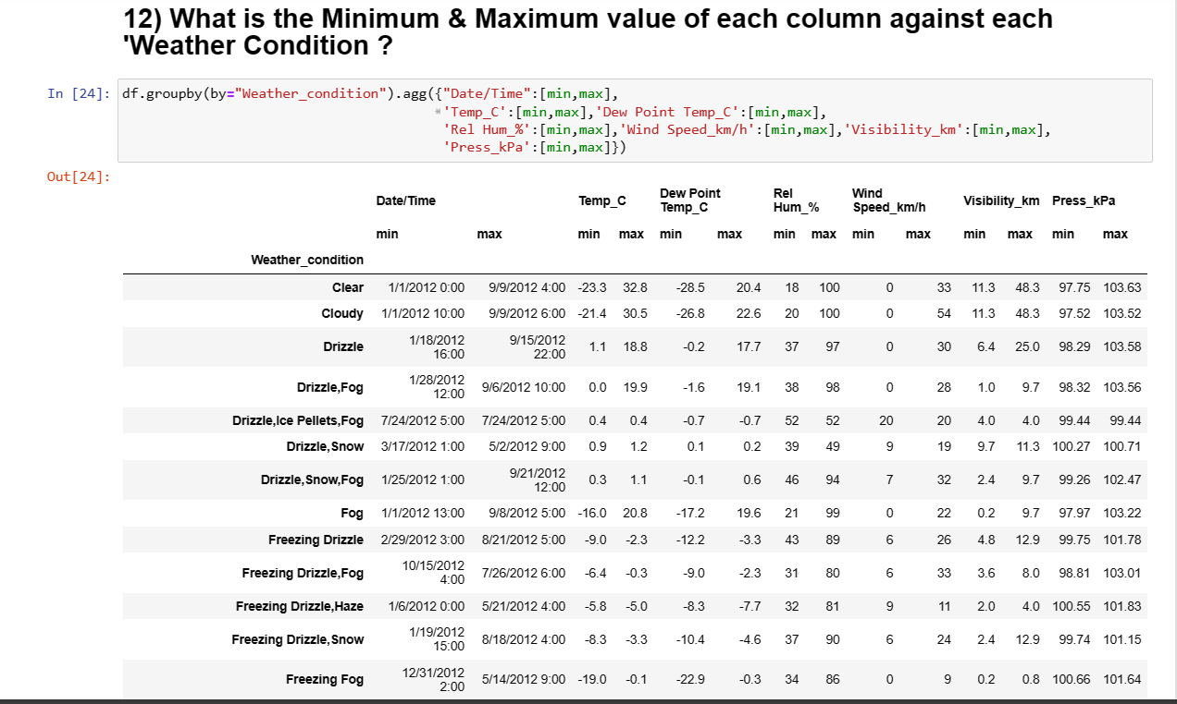

Syntax: df.groupby(by=”column_name”).agg({column_name:[min,max]})

Finding the minimum and maximum values of each column by set the weather_condition column as index.

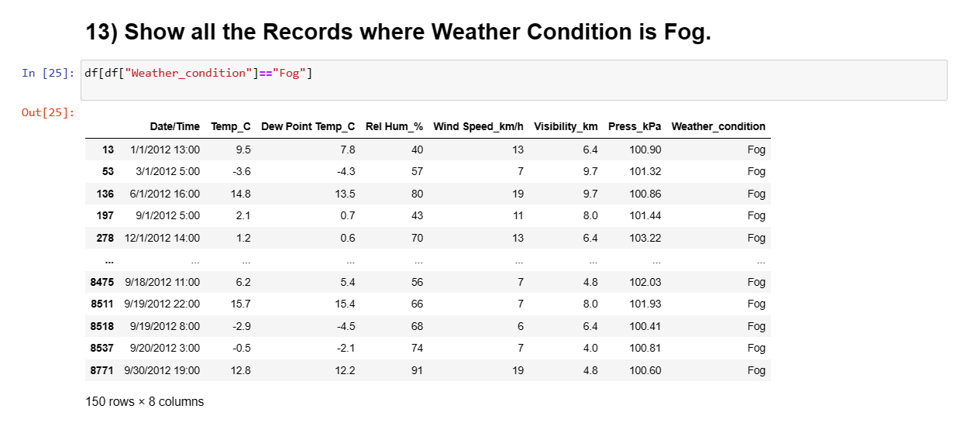

**Syntax: df[“column_name”]==values**.

Finding the weather_condition is equal to Fog.

I got 150 rows and 8 columns in my dataset.

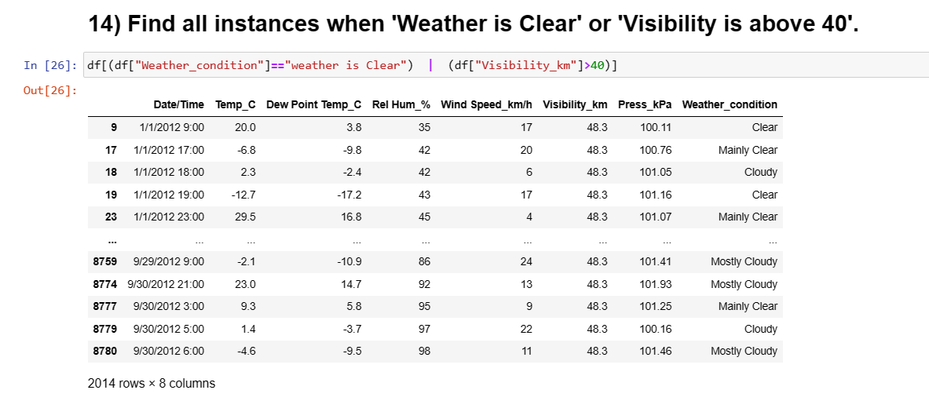

**Syntax:df[“column_name”]==”values”.**

In the above ,I have use the and ,or operaters to check the values of visibility having greater than 40 and weather_conditon value is equal to clear.

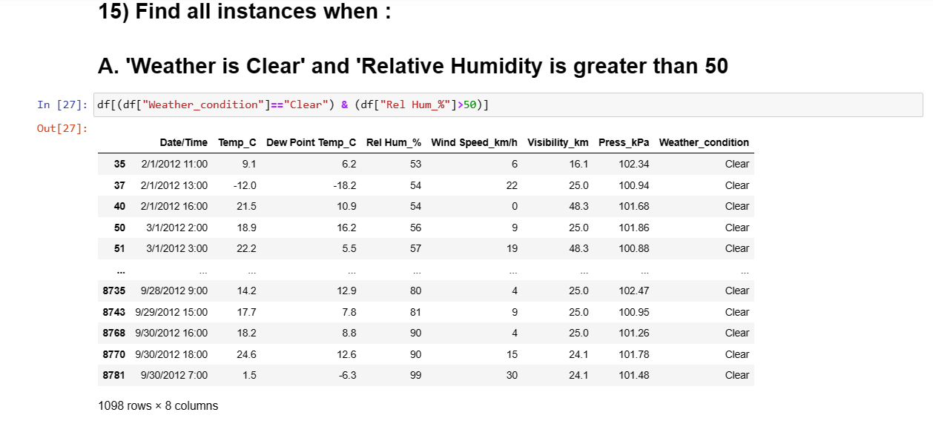

**Syntax:df[“column_name”]=”value”.**

In the syntax I have use the operator to check the weather_condition column is having value clear and Relative_Humdidty I use the greater than operator.

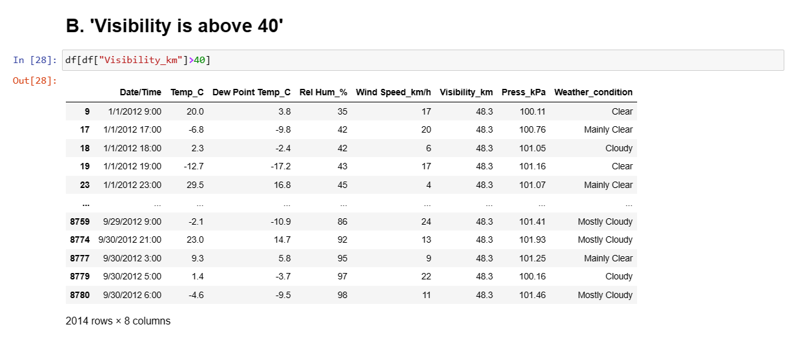

**Syntax:df[“column_name”]**

In the above syntax,I used the greater than operator to check the visibility column contains values greater than 40.